**Student Name**: N.DAWOODKHAN

PHASE-2

**Register Number:** 422623104305

**Institution:** UNIVERSITY COLLEGE OF ENGINEERING PANRUTI

**Department :** COMPUTER SCIENCE AND ENGINEERING

**Date of Submission : 10.05.2025**

**Git hub link :[ <https://github.com/Dawoodkhan-nazeer/Predicting-air-quality-levels-using-advanced-machine-learning-algorithms-for-environmental-insights.git>]**

# Problem Statement :

Air pollution poses a significant

threat to human health and the environment.

Predicting air quality levels accurately can help governments, industries, and citizens make

informed decisions to reduce exposure to pollutants. This is a classification problem, where the goal is to predict the Air Quality

Index (AQI) Category based on environmental

features like Ozone, Solar Radiation, Wind, Temperature, etc.

### Impact:

* Public health advisories
* Environmental policy making
* Smart city management
* Real-time alerts for citizens Awareness and Behaviour change

# Project Objectives:

* Build a machine learning model to classify air quality into categories like Good,

Moderate, Unhealthy, etc.

* Achieve high accuracy and interpretability.
* Identify key environmental factors influencing air quality.
* Develop visual insights for easier interpretation of results.
* Evolve the goal based on data exploration: focus on Ozone prediction and feature impact.
* Handle missing and noisy data efficiently
* Perform deep exploratory data analysis

(EDA)to understand relationships between features like wind, temperature, solar radiation, and ozone levels.

* Compare different machine learning models (like Random forest , decision trees, KNN, etc) to select the best-

performing algorithm for the dataset.

* Create easy to understand visualizations (feature importance plots, confusion matrices, correlation heatmaps) to communicate findings efficiently.
* Highlight how machine learning can be used for sustainability efforts and environmental protection through data-driven solutions.
* Design the project workflow in a way that it can adapt to larger or real-time dataset in

future extensions.

# Flowchart of the Project Workflow:

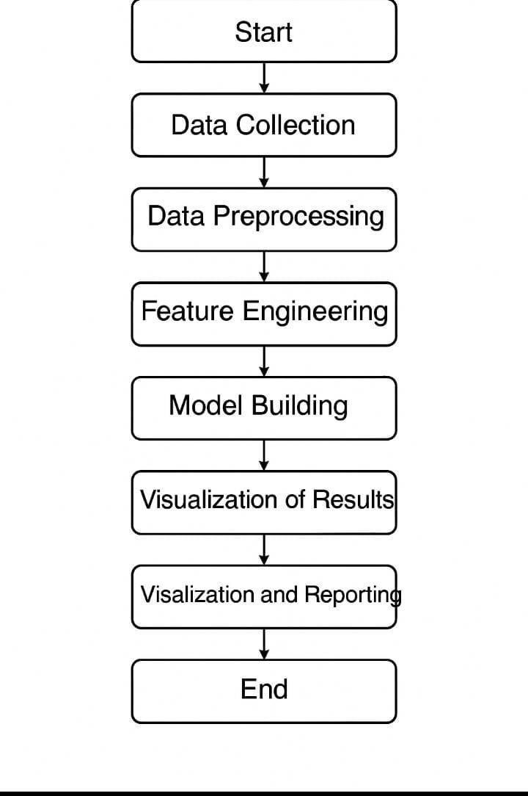

## Data Description

* Dataset Name: Air Quality Dataset.
* Source: Uploaded manually (original source from UCI Machine Learning Repository).
* Data Type: Structured data (tabular)
* Number of Records: 153 (after cleaning)
* Number of Features: 6 (Ozone, Solar, Wind, Temp, Month, Day)
* Dataset Nature: Static
* Target Variable: AQI Category (derived from Ozone levels)

## Data Preprocessing

* Missing Values: Rows with missing values were dropped for cleaner model building.
* Duplicates: Checked and found no duplicates.
* Outliers: Outlier handling not extensively applied in initial model.
* Encoding: AQI categorized into Good,

Moderate, and Unhealthy based on Ozone.

* Data Types: Ensured correct numerical types.
* Normalization/Scaling: Not applied initially (Random Forest is insensitive to feature

scaling).

# Exploratory Data Analysis (EDA)

* Univariate Analysis: Histograms for Ozone, Temp, Wind, Solar using distribution plots to observe outliers.

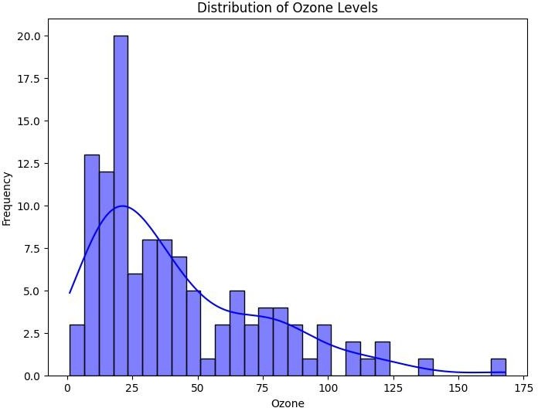

* Bivariate Analysis: Relationship between ozone and Month using box plot.

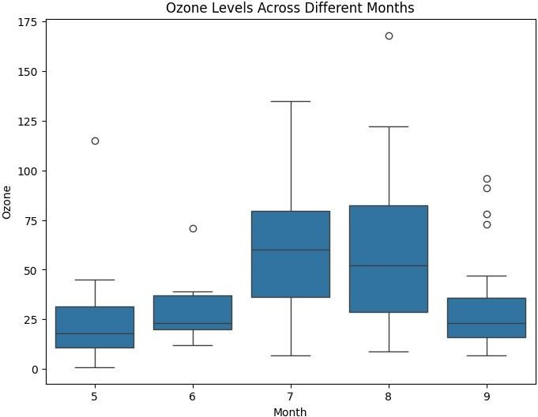

* Multivariate Analysis: Correlation matrix between multiple numeric features.

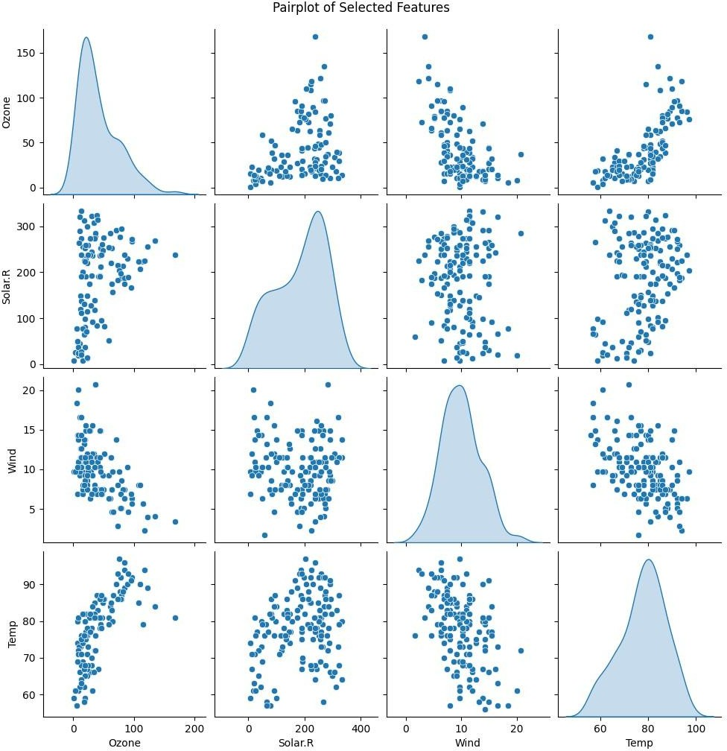

* Insights Summary: Ozone is negatively

correlated with Wind. Higher temperatures tend to have higher ozone concentrations.

Solar radiation also shows a moderate positive correlation with ozone levels.

* Correlation Analysis: Calculate Pearson

/spearman correlation. Plot correlation heatmap to identify strong relationships between variables.

* Feature distribution: compare feature distributions between different target classes. find potential features for classification or regression tasks.
* Outlier detection: Use boxplots and IQR method.

Identify and treat extreme value that could impact model performance.

## Feature Engineering:

* Created AQI_ Category: Based on Ozone values.
* Feature Selection: Dropped irrelevant columns like 'row names'.
* Feature Importance: Model- based feature importance extracted.
* Time-Based Feature: Hour of day, day of week, month, seasonality indicators. Lag features if predicting future pollution levels.
* Future Documentation: Keep a clear record of what feature were created/removed and why.

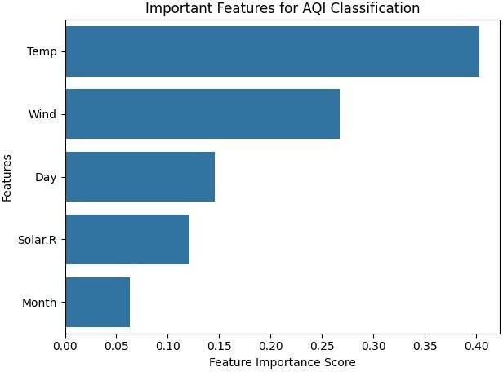

## Model Building:

* Models Used: Random Forest Classifier Decision Tree Classifier (for comparison)
* Reason for Model Choice: Suitable for

classification tasks. Handles non-linearities and feature interactions. Good

performance without heavy tuning.

* Evaluation Metrics: Accuracy Precision Recall F1-score
* Train-Test Split: 80% training, 20% testing

# Visualization of Results & Model Insights

### Pair chart:

* + - Pair plot help in understanding the relationship between different pairs numerical variables in a dataset.
    - Pair plots are helpful in detecting between

numerical features. strong correlation can be seen if the scatter plots show linear.

* + - Pair plots help identify potential issues of multicollinearity, where two

or more variables are highly correlated.

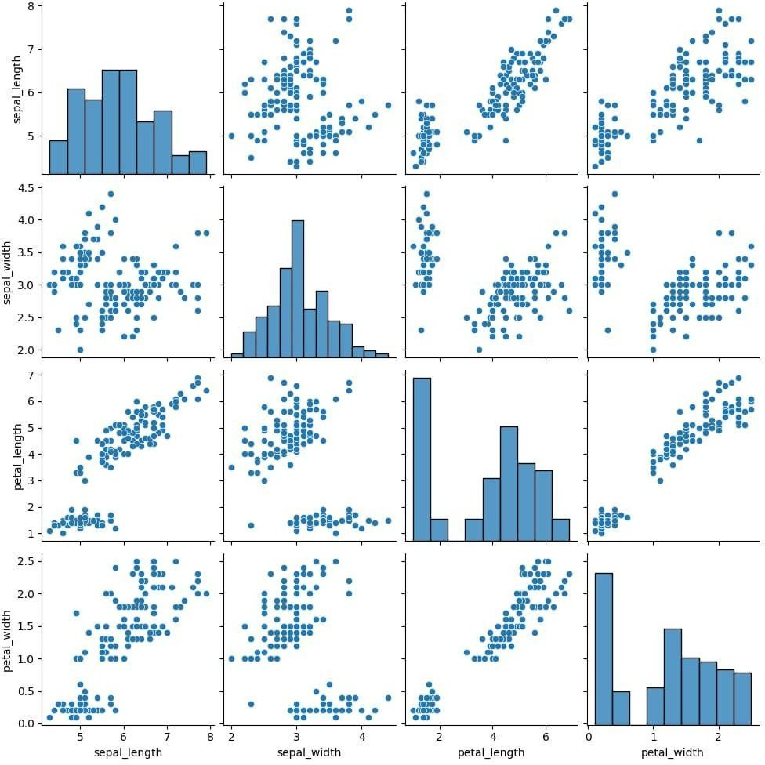

# Bar chart

* Bar plot showing which features influence AQI category prediction the most.
* Bar charts can show which features (E.g: Temperature, Wind, Solar, Radiation) are most influential in predicting ozone levels.
* Bar charts can be used to compare average ozone levels across different temperature ranges, wind speed categories.
* Bar charts can show the accuracy, precision and recall scores of different models (e.g:

Random forest).



## Pie Chart:

* A pie chart shows proportions or

percentages of different categories relative to the whole dataset. Showing distribution of AQI Model.

* A pie chart offer a simple and intuitive visual-easy for any audience to quickly understand the distribution.
* Helps in comparing the size of different groups (like “Good”, “Moderate”,

“Unhealthy”) air quality categories.

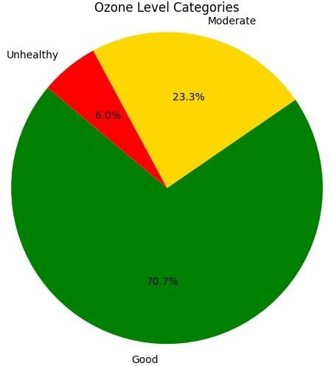

## Scatter Plot:

* Temperature is a strong predictors feature of air quality.
* High ozone levels during warm weather can cause poor air quality.
* Assess Model Accuracy Visually: If most

points are close to the dashed line, it means good predictive performance.

* If predictions are consistently above below line.
* In a scatterplot of temperature vs ozone.

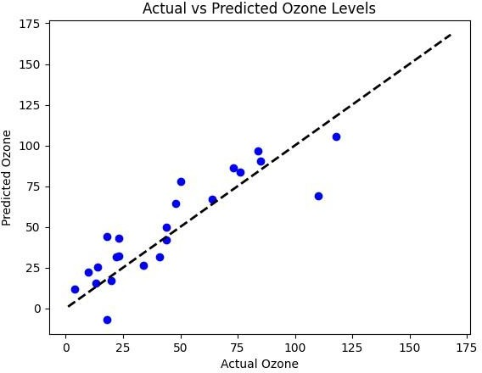

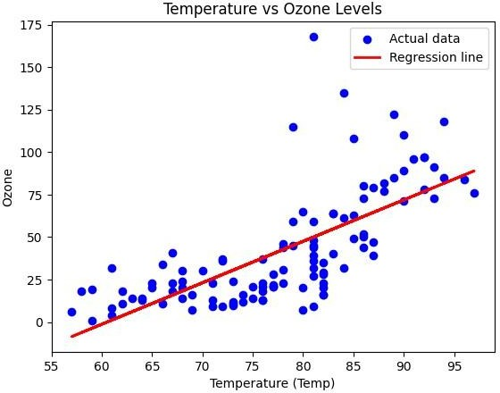

## Correlation of heatmaps

* + - Correlation heatmaps help you select important features or remove redundant ones before modelling.
    - A correlation heatmap visually shows the strength and direction of the two variables.
    - Dark Red/Blue colours indicate strong correlations. Light colours (close to white) show weak or no correlation.
    - Positive correlation (values near+1) usually appears red/orange colour.
    - Negative correlation (values near 1) usually appears blue**.**

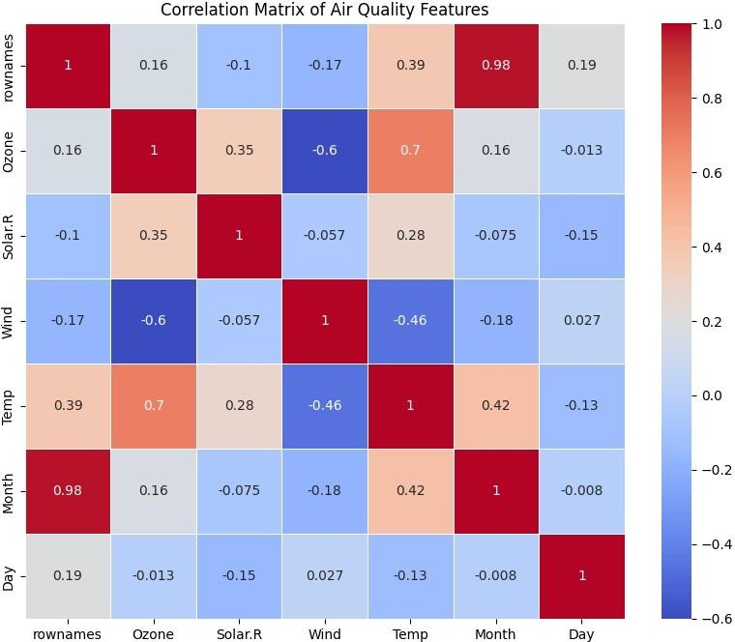

## Tools and Technologies Used:

* + - Programming Language: Python
    - IDE/Notebook: Google Colab
    - Libraries: pandas (data manipulation) NumPy (numerical operations) matplotlib and seaborn

(visualizations)

scikit-learn (modelling and evaluation)

* + - Deployment Tools (Optional): Stream lit (if deploying as a simple web app)
  + **Team members an roles**:

|  |  |  |
| --- | --- | --- |
| **Name** | **Role** | **RESPONSIBILITY** |
| A.ABIBRISCKILLA | **Project**  **Leader** | Oversee project development, coordinate team activities, ensure timely delivery of milestones, and contribute to documentation and final presentation. |
| R. RAGUL | Data manger | Collect data from APIs (e.g., Twitter), manage dataset storage, clean and preprocess text data, and ensure quality of input data. |
| T. JAYASUDHA | EDA and Visualization | Build sentiment and emotion classification models,  perform feature engineering, and evaluate model  performance using suitable metrics. |
| N.DAWOODKHAN | **Data Analyst**  **/ Visualization Lead** | Conduct exploratory data analysis (EDA), generate insights, and develop  such as word cloud,  emotion and sentiment  dashboards. |

|  |  |  |
| --- | --- | --- |
|  |  |  |
| T. KIRUBAKARAN | **Model Evaluation and**  **deployment Assistant** | Evaluation Model  Performing using metrics like accuracy and  classification report-  assisting with deployment readness summarizing  model results and suggesting improvements. |